Lab 4

Primitive Transformations

**Task #1: Image Negatives**

Implement a function for displaying negative of an input image. Note that the function must handle binary, grayscale, and RGB images. Example of RGB negative:

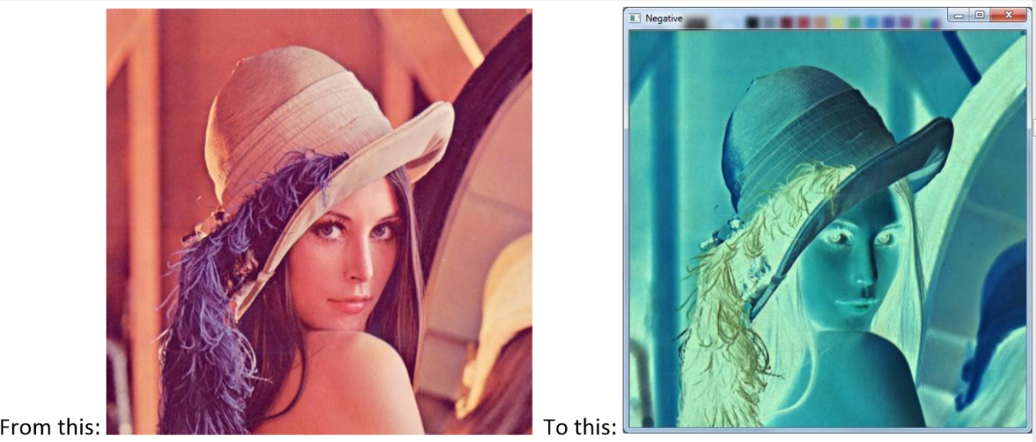

**Task #2: Image Gradients**

The horizontal gradient image can be used to detect vertical edges in an image. Implement a function for displaying the horizontal gradient of a grayscale image. The gradient can be approximated by forward differences:

$$I_{gradient}\left(x,y\right)=I\left(x+1,y\right)-I\left(x,y\right)$$

Note that the gradient values can be both positive and negative! So you need to find a way to display the gradient values in the range: 0, 1, 2, …, 255. The following link can be helpful here:

<https://www.cis.rit.edu/people/faculty/rhody/EdgeDetection.htm>

The resulting image should look something like this:

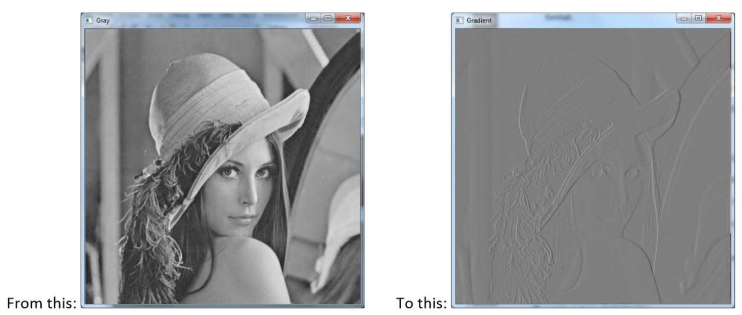

**Task #3: Bit Plane Slicing**

Perform bit slicing of an 8 bit greyscale image as discussed in the lecture. Start from the least significant bit and move towards the most significant bit. You will get eight binary images of the input image as demonstrated below.

